Software Design

CSC 414 Software Engineering I

WILLIAM BROWN

10\30\2020

Section 1.0: Scope

Web Based Currency Converter with Brief Historical and Educational Information, I wrote the bulk of this project in another class I ended up adding the national flags and historical information to make it an educational system, as well as, a helpful converter for international currencies.

Section 1.1: Identification

In this project a web-based currency converter will be made with the intention to give a brief educational overview of the history of each currency. Each currency will be accurately be converted between other currencies, using a free web-based or a written algorithm for each individual currency. Currencies will also have a brief subtext beneath the selection briefly explaining the history of the chosen currency. I will in this project be using Microsoft Visual Studio Code, and Notepad++ as my editors and for programming languages HTML, CSS, JavaScript; will be used.

Section 1.2: System Overview

The overall intention of this project is to offer a currency conversion software that is both easy to understand and educational to the user. This project will have an extremely simplistic design and graphic user interface, as to ensure that the user is not confused or overwhelmed by too much flare.

Section 1.3: Document Overview

In this documented portion I will briefly state the requirements and design of my project. The project requirements that I have set for myself for this project is to firstly produce a working currency conversion application. And then to add brief explanations of each currency with the interion to education the user with some brief history of each currency. The design philosophy for this project will be really simple. Essentially, I would like every aspect of the converter to be contained in its own little box to make it simplistic and easy to keep up with.

Section 2.0: Referenced Documents

References:

Section 3.0

Project Requirements: There are 180 cash currencies available in the World. In this project I will make a working converter for no less than 25 currencies. As well as, give a brief historical overview for a minimum of 10 currencies. Given the projects time constraints.

Table for Requirements Check List:7

|  |  |  |  |  |
| --- | --- | --- | --- | --- |
| Identifier Number | Requirement Statement | Test Planning | Test Results | Test: Pass/Fail |
| 1.01 | working Design Interface for the User | Test User Interfaces ease of use and simplicity | User Interface is simplistic and easy to use. | Pass |
| 1.02 | At least 25 working Currency Conversions | Have at least 25 working currency conversions | Currency converter works properly using an online API. | Pass |
| 1.03 | Add the flags for each working conversion | Accuracy check of the presented information | Flags are visible and accurate according to each country’s currency. | Pass |
| 1.04 | Brief History of Historical Background | Accuracy check of the presented information | Information is visible and accurate according to each country’s currency. | Pass |
| 1.05 | Final Iteration is working properly | Test all functions in the Project | According to the requirements all elements are in working order. | Pass |

Section 4.0

This is my initial idea as the layout for the user interface for my currency converter project. It seemed simple and simplistic enough to meet my requirements.

Project Design: First Iteration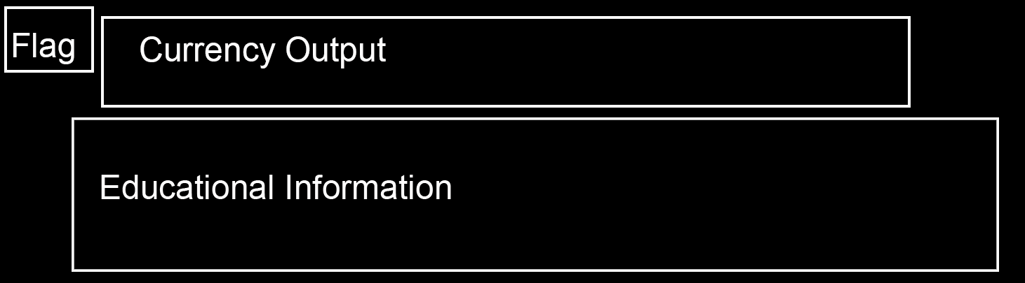

In the final design iteration, I ended up going from black and white to a dark blue and white color scheme as it was easier on the eyes when viewing.

Project Design: Final Iteration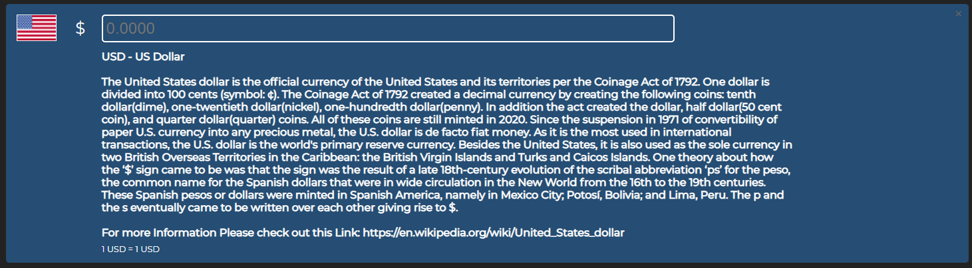

Section 5.0

During the testing phase each requirement was tested and checked for accuacy indepently to ensure that each requirement worked properly as intended.

Appendix

The test results for this project met the standards of the requirements that were set for the project.